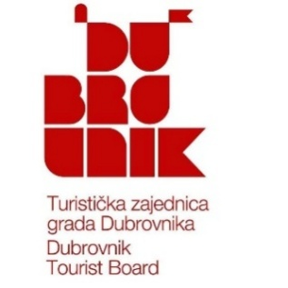 | 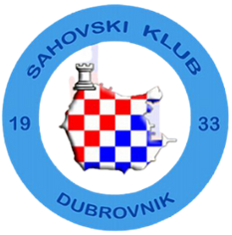  Open International Chess Tournament  Dubrovnik Advent 2025  Dubrovnik, December 18th – 21st, 2025 | 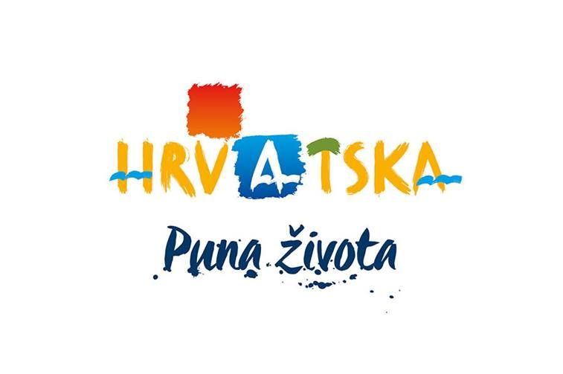

Organizer: | Chess Club Dubrovnik
Sponsors: | The City of Dubrovnik, Dubrovnik Tourist Board, Croatian National Tourist Board
Date: | December 18th – 21st, 2025
Playing Venue: | Valamar Lacroma Dubrovnik Hotel ☆☆☆☆, Iva Dulčića 34, 20000, Dubrovnik
Contact: | skdubrovnik@skdubrovnik.hr
System: | Swiss system, 7 rounds.  The tournament will be rated for the FIDE standard list.
Time Control: | 60 minutes per player + 30 seconds increment per move
Eligibility: | Open to all players with a valid FIDE ID and with ELO standard rating less than 2400 (maximum 2399) according to the December 1st, 2025 rating list
Entry Fees: | 20€ for Chess Club Dubrovnik members with their 2025 annual membership paid  40€ for others  * Entry fees must be paid to the bank account of Chess Club Dubrovnik by December 15th, 2025  ** Entry fees paid in cash on the day of the tournament are subject to a 5€ surcharge
Total Prize Fund: | 7.000 € distributed across 26 prizes

Main Prizes – Prizes by classification
1st prize: | 1200 € | 6th prize: | 300 €
2nd prize: | 900 € | 7th prize: | 250 €
3rd prize: | 600 € | 8th prize: | 200 €
4th prize: | 500 € | 9th prize: | 170 €
5th prize: | 400 € | 10th prize: | 170 €

Special prizes: | 1st prize | 2nd prize | 3rd prize
Best Female Players | 250 € | 150 € | 100 €
Juniors (2005. & younger) | 250 € | 150 € | 100 €
Seniors (1960. & older) | 250 € | 150 € | 100 €
ELO =< 1800 | 110 € | 60 € | 50 €
ELO 1801-2000 | 130 € | 80 € | 60 €
ELO 2001-2200 | 150 € | 100 € | 70 €
IMPORTANT NOTE: PRIZES ARE NON-CUMULATIVE! Prizes for EU participants will be paid to their bank accounts within 5 days.

Playing Schedule
Final registration: December 18th, 2025, from 11:00 to 14:30 at the playing venue.
Opening ceremony: December 18th, 2025, at 15:45.
Round 1: | Thursday | December 18th | 16:00
- Dinner break between Round 1 and Round 2
Round 2: | Thursday | December 18th | 20:00
Round 3: | Friday | December 19th | 13:00
Round 4: | Friday | December 19th | 17:00
Round 5: | Saturday | December 20th | 13:00
Round 6: | Saturday | December 20th | 17:00
Round 7: | Sunday | December 21st | 10:00
Prize-awarding and closing ceremony will begin immediately after the conclusion of the last round.
Chess sets and digital clocks will be provided by the Organizer.

Accommodation: Valamar Lacroma Dubrovnik Hotel ☆☆☆☆, Iva Dulčića 34, 20000, Dubrovnik

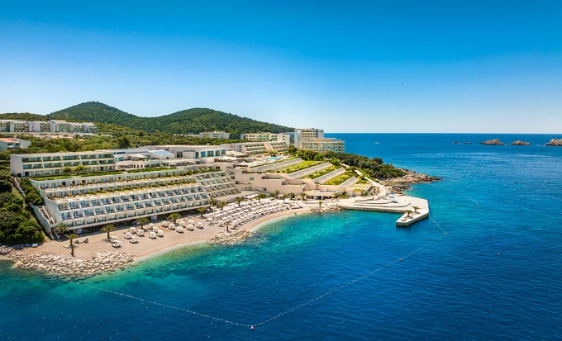 | 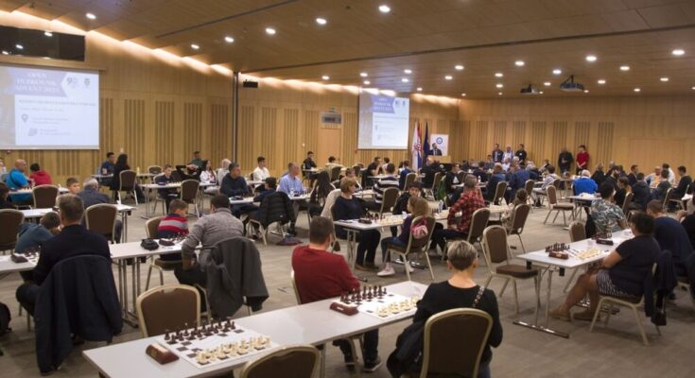
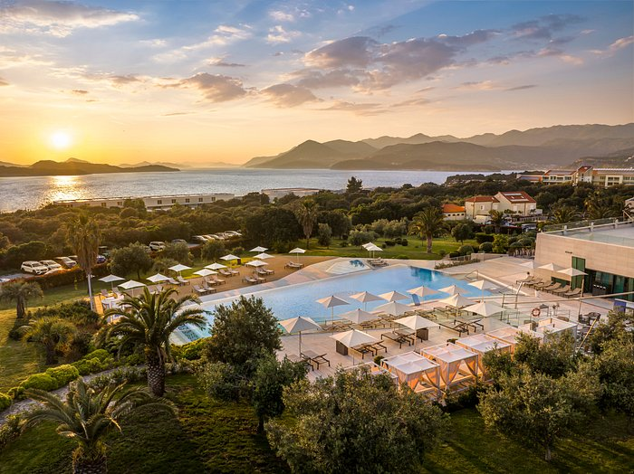 | 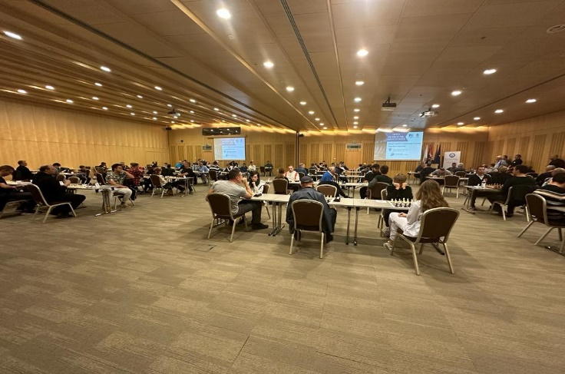

Discount prices for players and their companions:
- Bed and Breakfast: Double room – 62 € per person, Single occupancy – 92 €
- Half Board: Double room – 70 € per person, Single occupancy - 100 €
* Half board includes buffet breakfast and buffet dinner. Drinks are not included.
** Tourist accommodation fee is included.
*** Price discounts:
- 100% for a child up to 2 years old sharing a room with two adults
- 50% for a child aged 2-12 years old sharing a room with two adults
- 20% for people over 12 years old sharing a room with two adults
**** In case of cancellation, the hotel's cancellation policy will apply. Details are available upon request.
The listed accommodation prices are only available for bookings and payments made through Chess Club Dubrovnik.

As capacity is limited, reservations can only be guaranteed upon receipt of payment.

BANK ACCOUNT DETAILS:
ŠK Dubrovnik,  Liechtensteinov put 12, Dubrovnik  20000 Dubrovnik | IBAN: HR8224070001100022033

REGISTRATION, ACCOMMODATION, & ALL OTHER INFORMATION: skdubrovnik@skdubrovnik.hr

Protection of Personal Data (GDPR notice): By registering for the tournament, participants agree that personal data necessary for the organization of the competition (such as name, age, chess rating and title, federation, club or team membership, etc.), as well as photos and games from the tournament, may be published on the Organizer's official website and in the media.

Advent Program: During the Advent period, a rich cultural and entertainment program will be offered at several locations in Dubrovnik. Participants are invited to explore this aspect of the city’s touristic offerings. More information is available at: https://www.dubrovackizimskifestival.com/

NOTE: The Organizer reserves the right to make minor changes and technical adjustments to the tournament regulations up to one week prior to the event.

Welcome!

